What is OOPs?
OOPs (Object-Oriented Programming System) is a programming paradigm based on the concept of "objects", which are instances of classes. It helps you design programs by modeling real-world entities using data (attributes) and functions (methods).
Object-Oriented Programming is a way of writing programs where you model everything as objects — just like in real life.
An object in object-oriented programming is a real instance of a class, and it contains both:
1. Data (Attributes / Variables / State)
These describe the properties of the object.
Example:
A Car object might have:
- brand = "Tesla"
- color = "red"
- speed = 100
2. Functions (Methods / Behavior)
These define what the object can do — its actions.
Example:
A Car object might have:
- drive()
- brake()
- honk()

What is a Class in Object-Oriented Programming?
A class is like a blueprint, template, or design for creating objects.

Benefits of OOP:
- Modular code (broken into classes)
- Code reusability via inheritance
- Scalability for large applications
- Security via access control (private/protected)

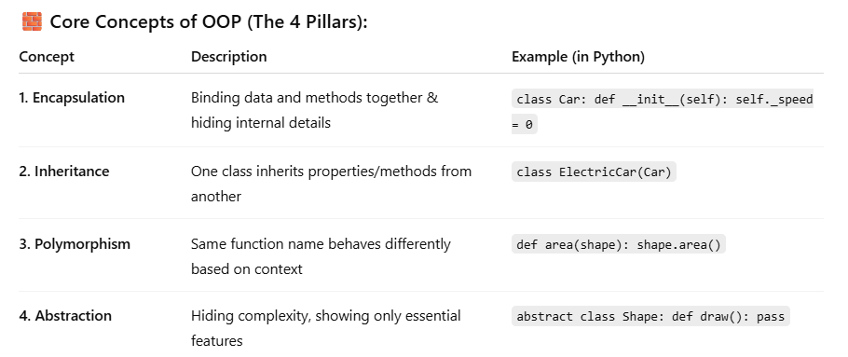
1. Encapsulation
"Hiding the internal details and exposing only what's necessary."
- It bundles data and methods that operate on the data into a single unit: the object.
- Helps in protecting data from unauthorized access or unintended changes.
Example:
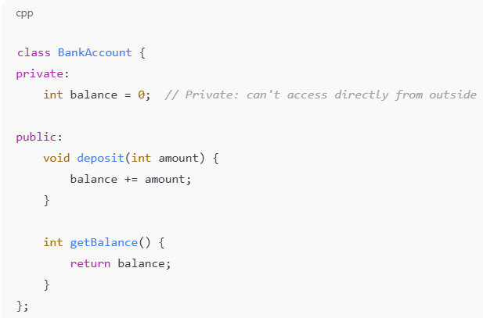
You can't directly change balance from outside. You must use deposit() and getBalance().

2. Inheritance
"Acquiring properties and behaviors from another class."
- One class (child) can reuse the code of another class (parent).
- Promotes code reuse and hierarchy.
Example:
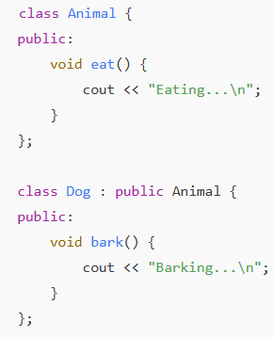
Now Dog has both eat() and bark() methods — it inherits eat() from Animal.

3. Polymorphism
"One interface, many forms."
- The same method name can behave differently depending on the object or context.
- Achieved via function overriding or overloading.
Example
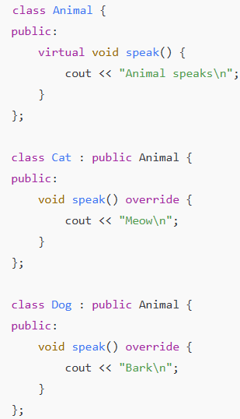
Animal* a = new Dog();
a->speak(); // Output: Bark
4. Abstraction
"Showing only essential features, hiding the rest."
- Focuses on what an object does instead of how it does it.
- Helps in reducing complexity for the user.
Example:
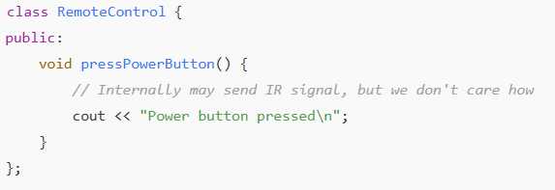

Difference between Encapsulation and Abstraction
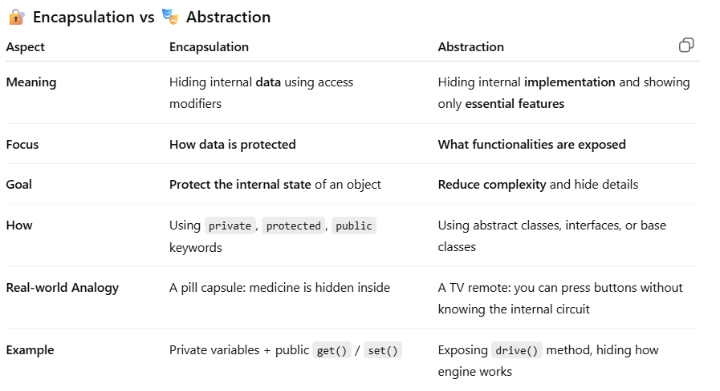

Method Overloading and Overriding
Overloading (Same class, different parameters)
Means defining multiple functions with the same name but different parameters (type, number, or order).
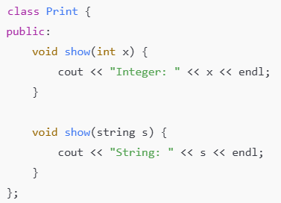
Print p;
p.show(5); // Integer: 5
p.show("Hello"); // String: Hello

Overriding (Subclass redefines a method from parent)
Means redefining a base class method in a derived class with the same signature (name and parameters).
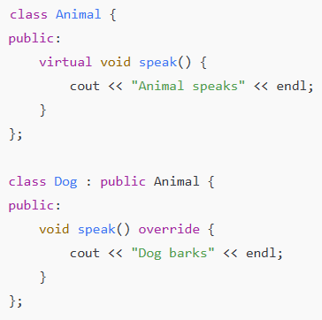
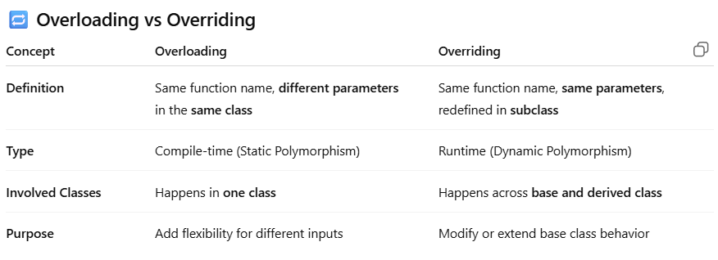
What is a constructor?
The constructor is a special function inside a class that is automatically called when you create an object of that class
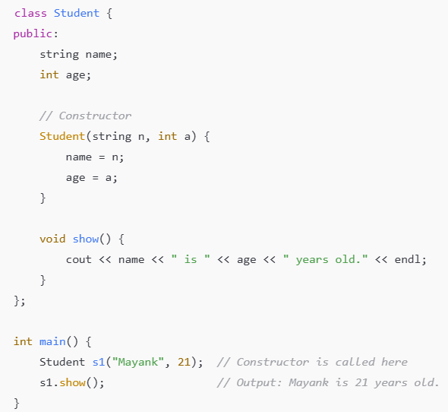

What is Constructor Overloading?
Constructor overloading means defining multiple constructors in the same class, but each with different parameter lists (number, type, or order of parameters).
It allows you to create objects in different ways depending on what information you have at the time of object creation.
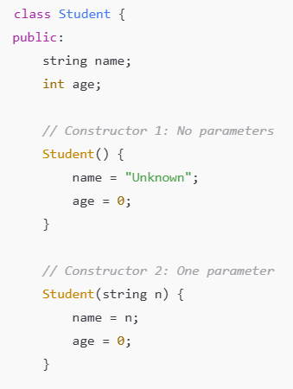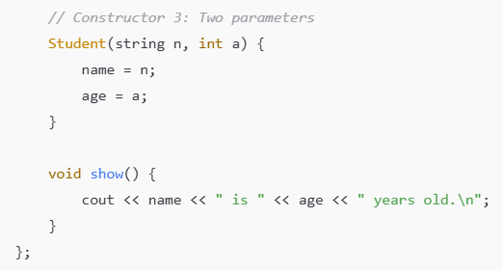
Student s1; // Uses constructor 1
Student s2("Mayank"); // Uses constructor 2
Student s3("Aman", 21); // Uses constructor 3
s1.show(); // Unknown is 0 years old.
s2.show(); // Mayank is 0 years old.
s3.show(); // Aman is 21 years old.

What is a Destructor in OOP?
A destructor is a special function in a class that is automatically called when an object is destroyed.
It is used to:
- Free memory
- Close files
- Release resources

Key Reasons OOP is Important:
1. Modularity
- Code is organized into classes and objects.
- Each class encapsulates data and behavior — like a real-world entity.
- Makes large projects easy to structure and manage.
Think of each class like a Lego block. You build a complex structure by combining them.
2. Reusability (via Inheritance)
- Once a class is written, it can be inherited to create new classes with minimal code duplication.
- Promotes code reuse across the system.
Example: A Vehicle class can be reused by Car, Bike, Bus classes.
3. Scalability
- OOP systems are easier to scale as your project grows.
- Adding new features often just means adding a new class or extending existing ones.
4. Maintainability
- Because of encapsulation, changes in one part of the code usually don’t affect others.
- Bugs are easier to isolate and fix.
5. Abstraction
- Hides internal implementation and shows only what is necessary.
- Developers can use classes without knowing the internal logic.
Like using a TV remote — you press buttons, but don’t need to know how it works inside.
6. Encapsulation
- Keeps data safe from outside interference and misuse.
- Makes your objects more secure and stable.
7. Improves Collaboration
- OOP makes it easier for teams to divide work into separate modules or classes.
- Teams can work independently on features without breaking each other's code.

